Student’s name | …………………………………………………….…… | Grade | 1
Subject | Computer | Week No. | 10
Lesson Title | Type with keyboard | Unit
Worksheet No. ( 10 )

write the correct name of each part

File | Notepad | Speaker

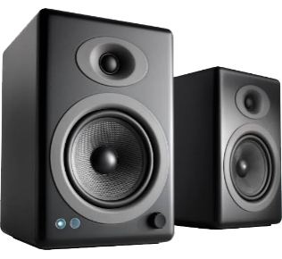

Good Luck

